Online supporting information

Table S1 Summary statistics for eight microsatellite loci for brook trout collected in Kent Falls Brook and Jefferson Hill-Spruce Brook. Number of individuals genotyped (n), number of alleles (A), expected (H_{E}) and observed (H_{O}) heterozygosity, inbreeding coefficient (F_{IS}), and probability (P) of departure from Hardy-Weinberg expectations in the direction of heterozygote deficiency are shown. P-values with an asterisk (*) indicate statistical significance after applying a sequential Bonferroni correction for multiple comparisons (P-value < 0.006).
 | SfoC-113 | SfoD-75 | SfoC-88 | SfoD-100 | SfoC-115 | SfoC-129 | SfoC-24 | SsaD-237
 | Kent Falls Brook (n = 267)
H_{E} | 0.596 | 0.579 | 0.209 | 0.743 | 0.836 | 0.537 | 0.547 | 0.847
H_{O} | 0.581 | 0.547 | 0.195 | 0.715 | 0.813 | 0.494 | 0.562 | 0.835
A | 5 | 6 | 4 | 10 | 16 | 5 | 5 | 18
F_{IS} | 0.026 | 0.056 | 0.069 | 0.037 | 0.028 | 0.079 | -0.028 | 0.014
P | 0.303 | 0.043 | 0.126 | 0.121 | 0.012 | 0.254 | 0.097 | 0.106
 | Jefferson Hill-Spruce Brook (n = 473)
H_{E} | 0.792 | 0.821 | 0.732 | 0.691 | 0.874 | 0.710 | 0.537 | 0.922
H_{O} | 0.755 | 0.765 | 0.660 | 0.660 | 0.869 | 0.679 | 0.514 | 0.871
A | 11 | 15 | 6 | 8 | 17 | 7 | 4 | 24
F_{IS} | 0.047 | 0.067 | 0.099 | 0.045 | 0.005 | 0.044 | 0.043 | 0.055
P | 0.013 | 0.012 | 0.000* | 0.036 | 0.062 | 0.004* | 0.081 | 0.000*

Table S2 Pair-wise F_{ST} between genetic clusters in Jefferson Hill-Spruce Brook. See Figs. 4(b) and 5 for spatial locations of the clusters.
 | JeffDown | JT1 | JT2+ | JT3+ | Spruce
JeffDown
JT1 | 0.034
JT2+ | 0.008 | 0.046
JT3+ | 0.004 | 0.041 | 0.005
Spruce | 0.025 | 0.085 | 0.046 | 0.035

Table S3 The number of brook trout individuals genotyped (N), mean expected heterozygosity (H_{E}), mean observed heterozygosity (H_{O}), and mean allelic richness (A_{R}) across eight microsatellite loci for the five genetic clusters in Jefferson Hill-Spruce Brook (see Figs. 4(b) and 5).
 | N | H_{E} | H_{O} | A_{R}
JeffDown | 98 | 0.764 | 0.716 | 10.00
JT1 | 30 | 0.746 | 0.721 | 8.75
JT2+ | 69 | 0.763 | 0.734 | 8.88
JT3+ | 55 | 0.754 | 0.736 | 9.25
Spruce | 221 | 0.720 | 0.717 | 10.13

Table S4 Pair-wise F_{ST} between genetic clusters in Kent Falls Brook. See Fig. 7(b) for spatial locations of the clusters.
 | KentDown | KentMiddle | KentUp | KT4
KentDown
KentMiddle | 0.011
KentUp | 0.027 | 0.007
KT4 | 0.013 | 0.009 | 0.014

Fig. S1 Longitudinal patterns of fish count of two size classes (81-140 mm and > 140 mm) by 50m reach in Kent Falls Brook, Jefferson Hill Brook and Spruce Brook in late summer of 2008.

Fig. S2 Longitudinal profiles of (a) elevation and (b) late-July mean stream temperature in Jefferson Hill Brook and Spruce Brook from their confluence.

Fig. S1
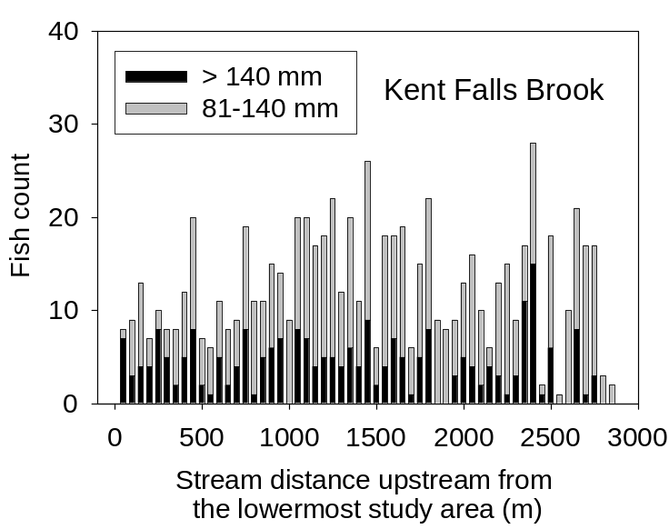

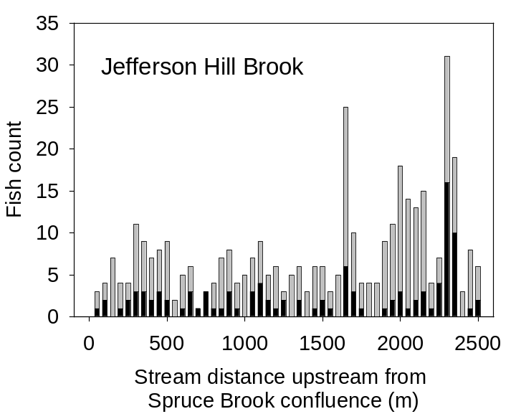
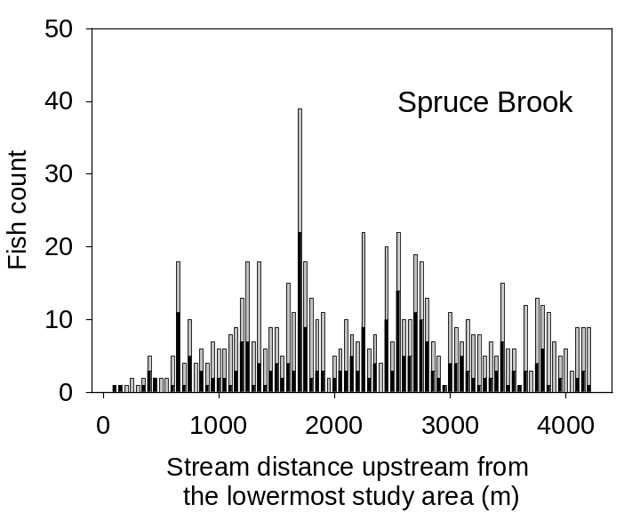
Seasonal barrier
Fig. S2

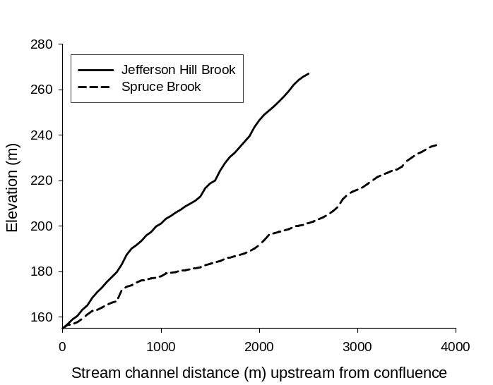
(a)
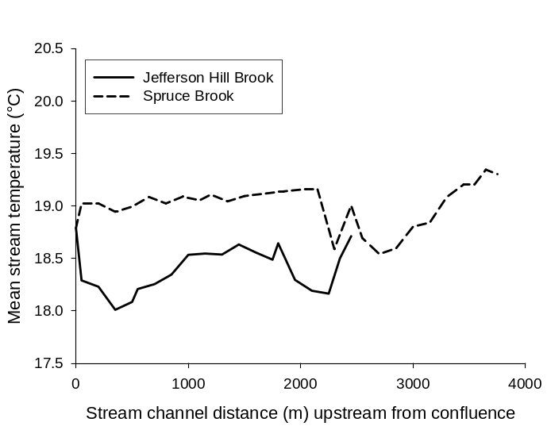
(b)

